# Data Visualization

# (01CE0614)

**Department of Computer Engineering**

**6th Semester**

# Lab Manual

# (Jan-May, 2025-26)

|  |  |  |  |
| --- | --- | --- | --- |
| **Student Name** | Asif Alam | **Enrollment No.** | 92201703058 |
| **Subject Name (Subject code)** | Data Visualization (01CE1614) | **Semester (Class)** | 6 EC-3 |
| **Batch (A/B/C)** | B | **Lab/ Week** | 1 Lab |

|  |  |  |  |  |
| --- | --- | --- | --- | --- |
| **S.**  **No.** | **Experiment Title** | **Date** | **Page**  **No.** | **Sign.** |
| 1 | Create a line chart to show trends over time |  |  |  |
| 2 | Create a pie chart to show the distribution  of data |  |  |  |
| 3 | Create a scatter plot to show the  relationship between two variables |  |  |  |
| 4 | Create a histogram to show the distribution  of a continuous variable |  |  |  |
| 5 | Create a heatmap to show the relationship  between two or more variables |  |  |  |
| 6 | Create a treemap to show the hierarchical  structure of data |  |  |  |
| 7 | Create a map to show the geographic  distribution of data |  |  |  |
| 8 | Create a dashboard to combine multiple  visualizations into a single view |  |  |  |
| 9 | Use filters and groups to explore your data  in different ways |  |  |  |
| 10 | Use custom formatting to improve the  appearance of your visualizations |  |  |  |
| 11 | Use custom formatting to improve the  appearance of your visualizations |  |  |  |
| 12 | Visualize the sales of a company by product  category and region |  |  |  |
| 13 | Track the performance of a marketing  campaign over time |  |  |  |
| 14 | Analyze customer behavior and identify  trends |  |  |  |
| 15 | Create a dashboard to track key performance indicators (KPIs) for a  business |  |  |  |

1. **Create a line chart to show trends over time.**

* **Definition:** A line chart is a graph that uses lines to connect data points to show changes in value over time. It's also known as a line graph, line plot, or curve chart.
* **Application:** Line charts are used to track changes in data over time, and to compare changes between groups. They can also be used to identify patterns and correlations in data.
* **Dataset / Data source: IPL Season (2008-2022)**

**Dataset: IPL Season**

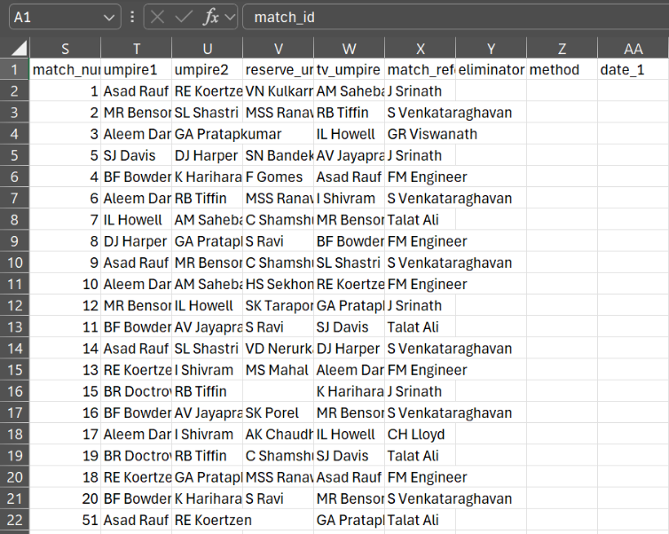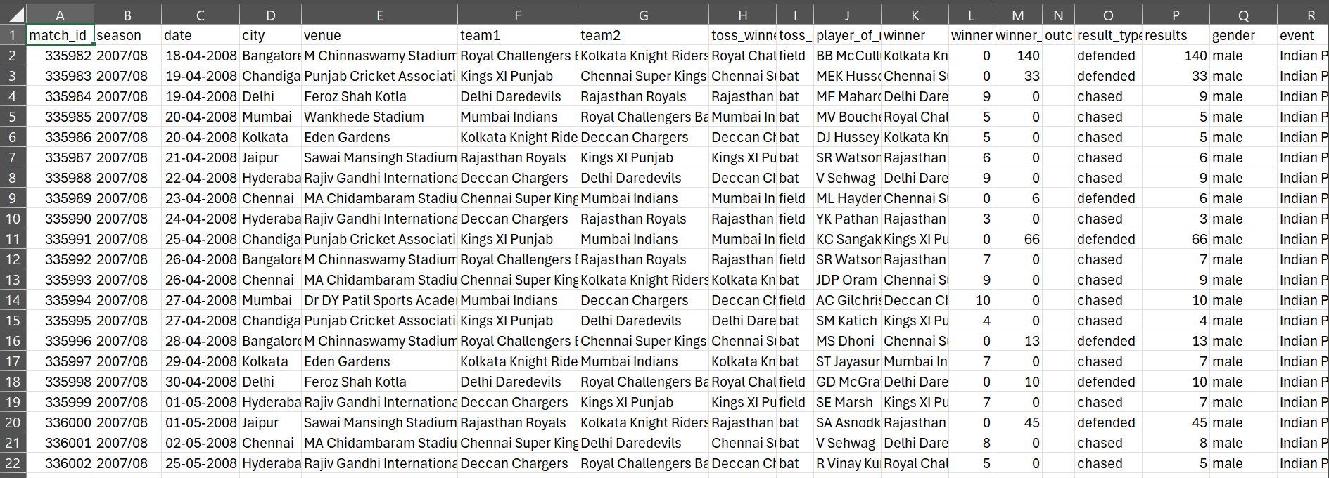

* Import the IPL dataset in tableau

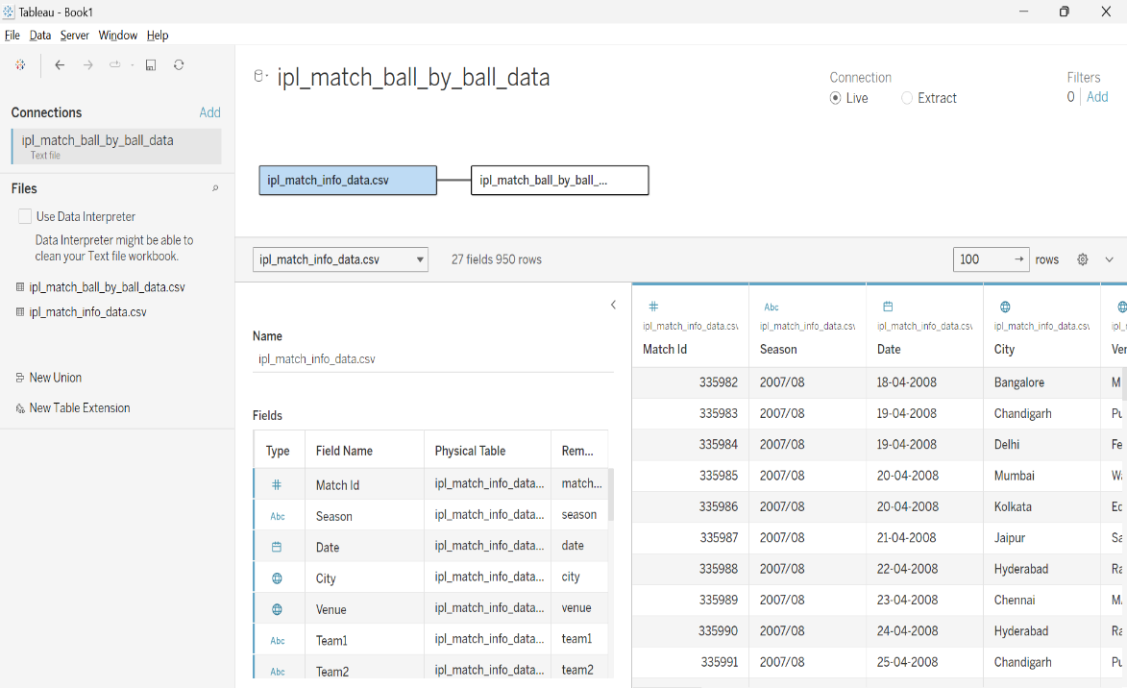

* Drag number of match count in row and year in column
* Line chart of Matches played per Year or Season

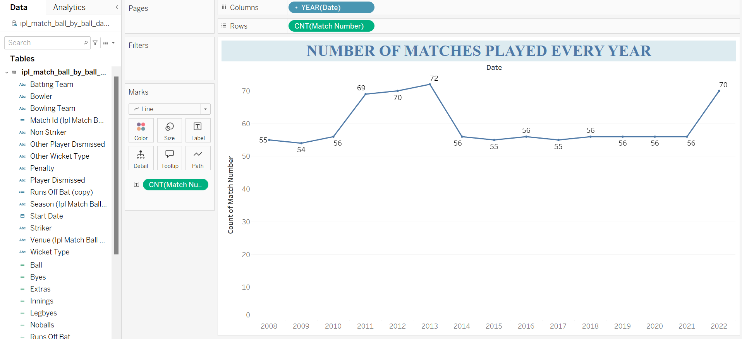

1. **Create a pie chart to show distribution of data.**

* **Definition:** A diagram consisting of a circle divided into parts to show the size of particular parts in relation to the whole
* **Application:** Pie charts are used to show the percentage of a whole, or how different parts relate to the whole. They are often used in business to compare data like revenue, profits, and customer types.
* **Dataset / Data source: IPL Season (2008-2022)**

Same dataset is used as Practical 1. (IPL Season (2008-2002)).

* Drag Toss Decision in rows and match winner in column
* Pie chart of Teams with number of matches win after winning the toss.

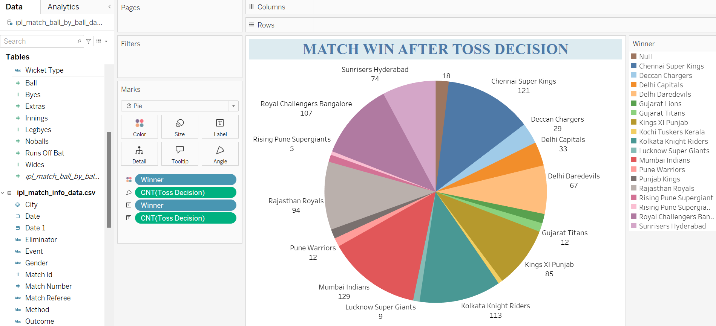

1. **Create a scatter plot to show the relationship between two variables.**

* **Definition:** Scatter plots are the graphs that present the relationship between two variables in a data-set.
* **Application:** Scatter plots are used to show relationship analysis, shows how two variables relate to each other, helps identify if there’s positive, negative, or no correlation.
* **Dataset / Data source: IPL Season (2008-2022)**

Same dataset is used as Practical 1 (IPL Season (2008-2022))

* Drag Runs off Bat in column and Ball in rows

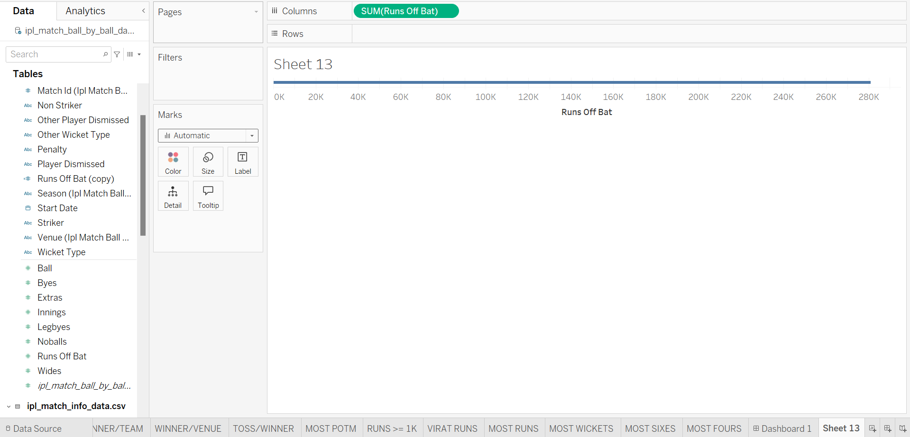

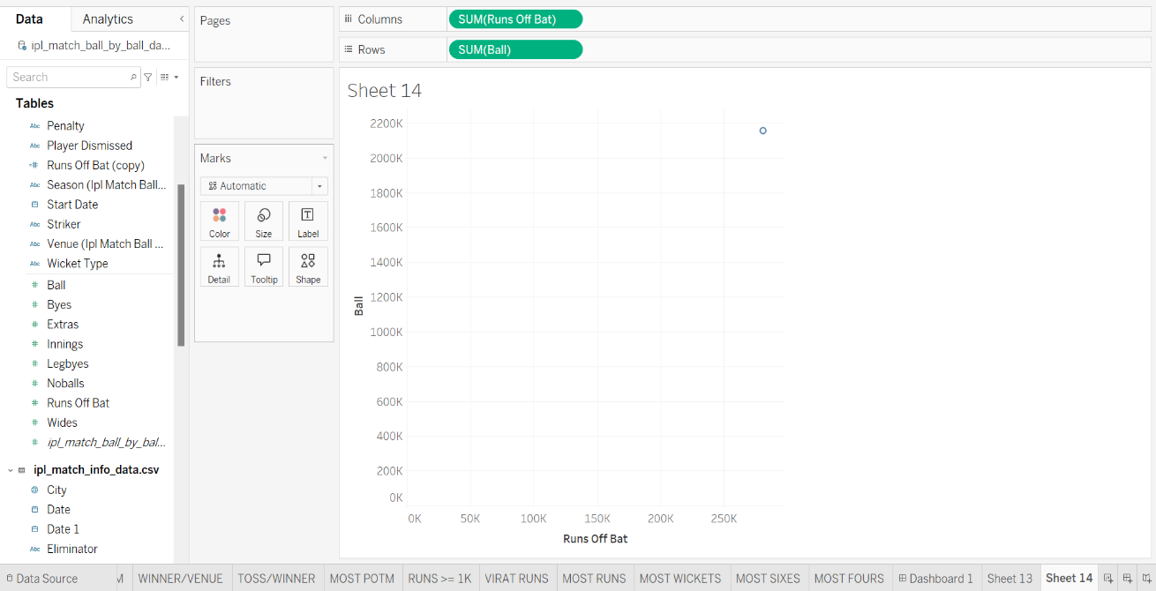

* Scatter chart of Runs scored V/S Ball Faced

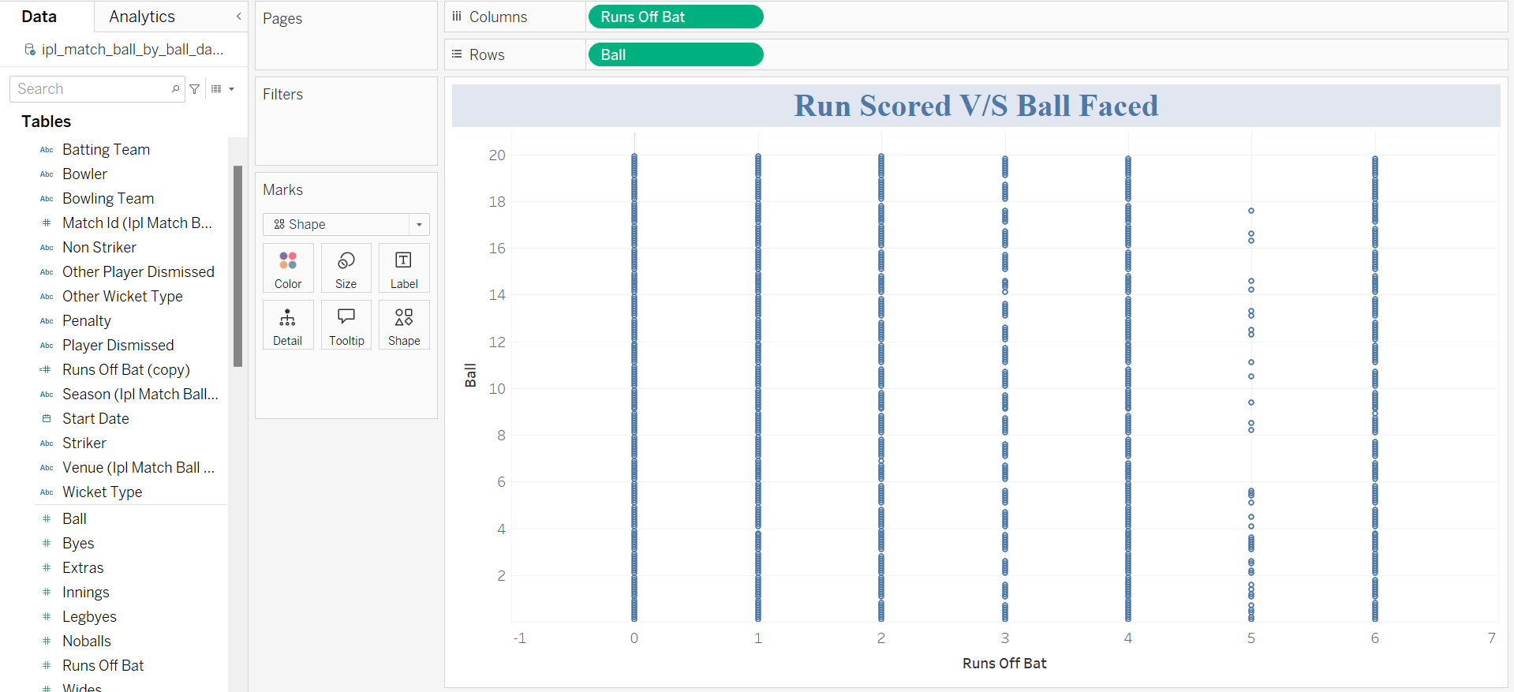

1. **Create a histogram to show the distribution of a continuous variable**

* **Definition:** A diagram consisting of rectangles whose area is proportional to the frequency of a variable and whose width is equal to the class interval.
* **Application:** Histograms are used in many fields to analyze and visualize data. They are useful for summarizing large data sets, identifying patterns, and comparing data.
* **Dataset / Data source:** IPL Season (2008 - 2022)

Same dataset is used as Practical 1 (IPL Season (2008-2022))

* Drag Winner field to Columns

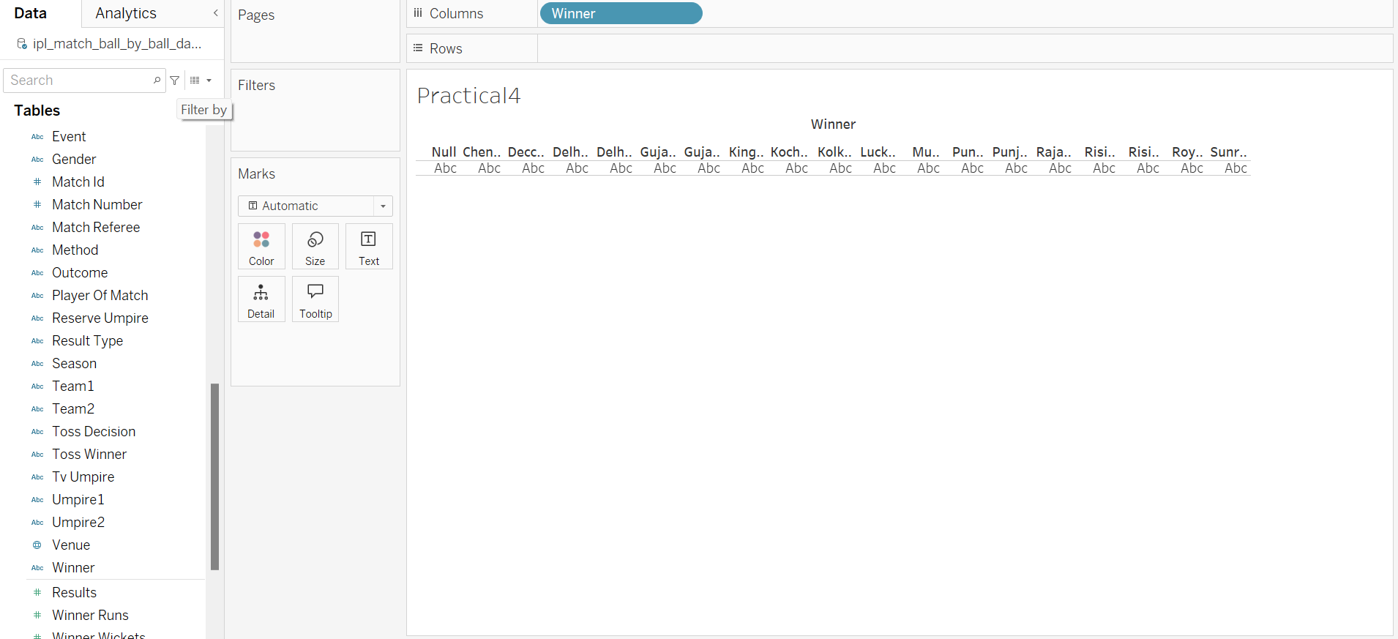

* Drag Match Number field to Rows

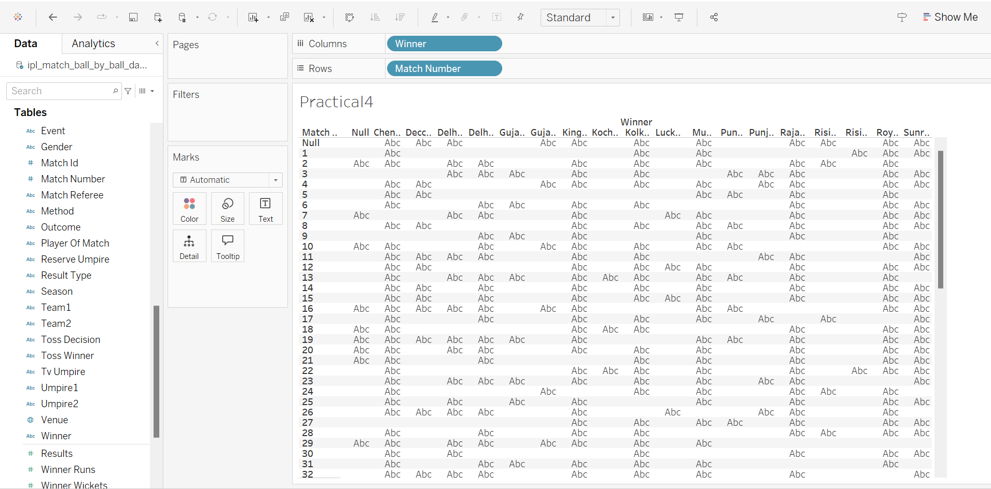

* Convert Match Number field -> Measure -> Count

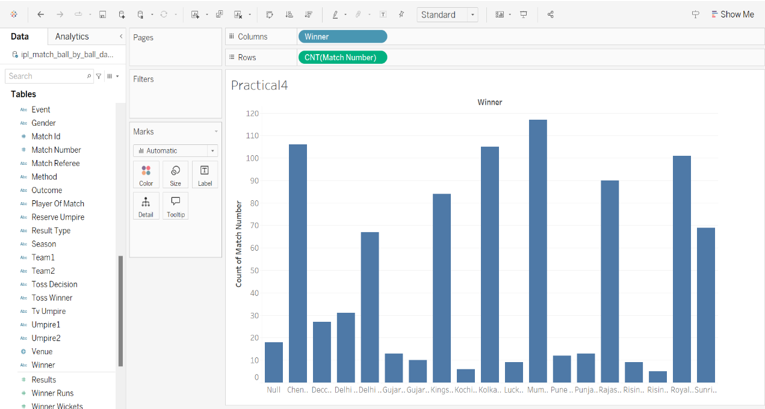

* 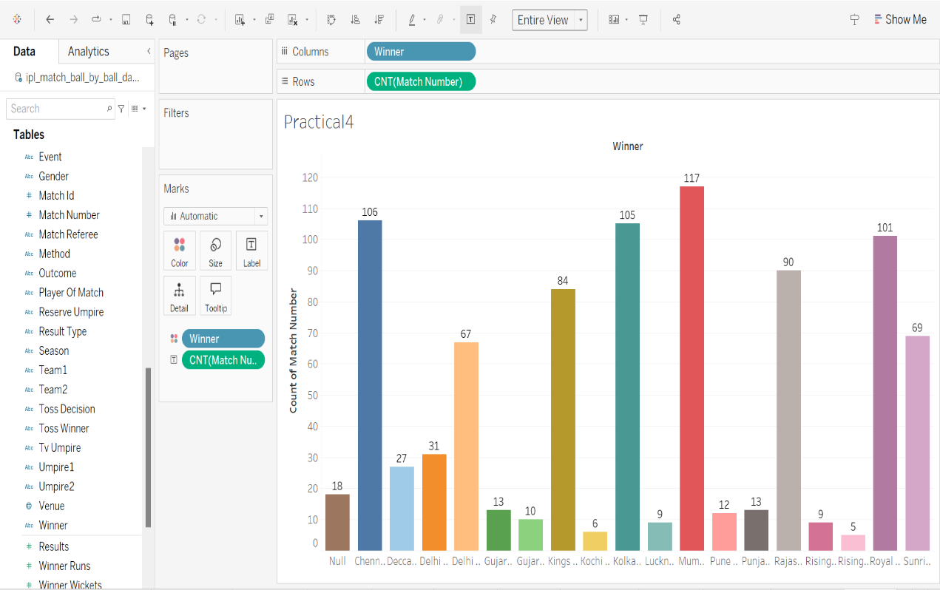Drag Winner to Color and Match Number (Count) to Label

**Number of Matches won by every team in IPL history using Histogram**

1. **Create a heatmap to show the relationship between two or more variables.**

* **Definition:** A representation of data in the form of a map or diagram in which data values are represented as colours.
* **Application:** Heatmaps are used in various forms of analytics but are most commonly used to show user behaviour on specific web pages or webpage templates.
* **Dataset / Data source:** IPL Season (2008 - 2022)

Same dataset is used as Practical 1 (IPL Season (2008-2022))

* Drag Wicket Type to rows

* Drag Player Dismissed to Color in Marks

* Right click on Player Dismissed to select count of wickets

* Convert Automatic to Density in Marks

**Number of Players dismissed by different Wicket type using Heatmap.**

1. **Create a treemap to show the hierarchical structure of data.**

* **Definition:** A treemap is a visualization tool that uses nested rectangles to show hierarchical data.
* **Application:** Treemaps are used to visualize hierarchical data by organizing it into a tree structure.
* **Dataset / Data source:** IPL Season (2008 - 2022)

Same dataset is used as Practical 1 (IPL Season (2008-2022))

* 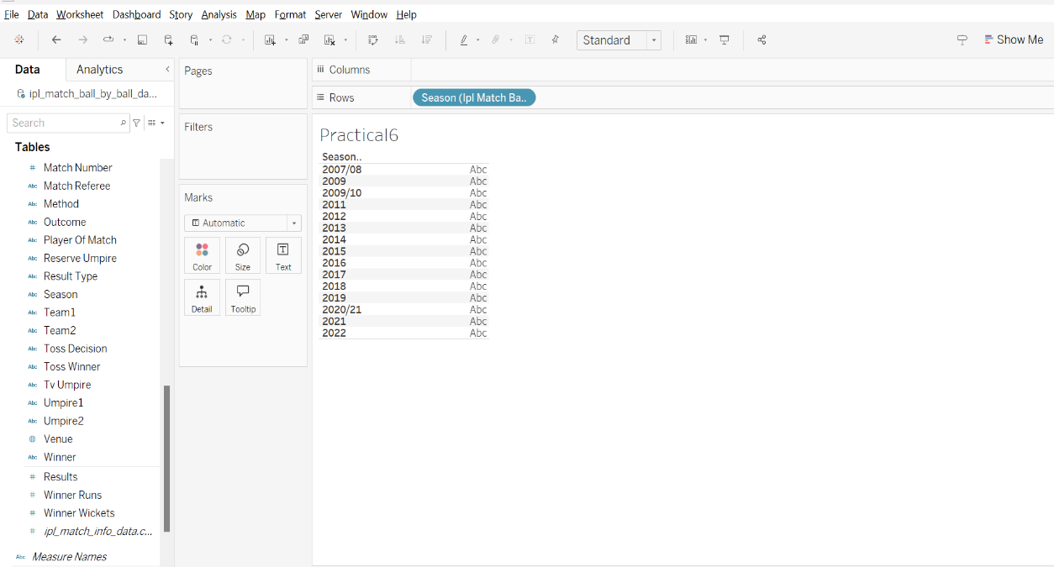Drag Season field to rows
* Drag Player Of Match field to Rows

* Drag Match Number field to Rows and convert it to CNT(Match Number)

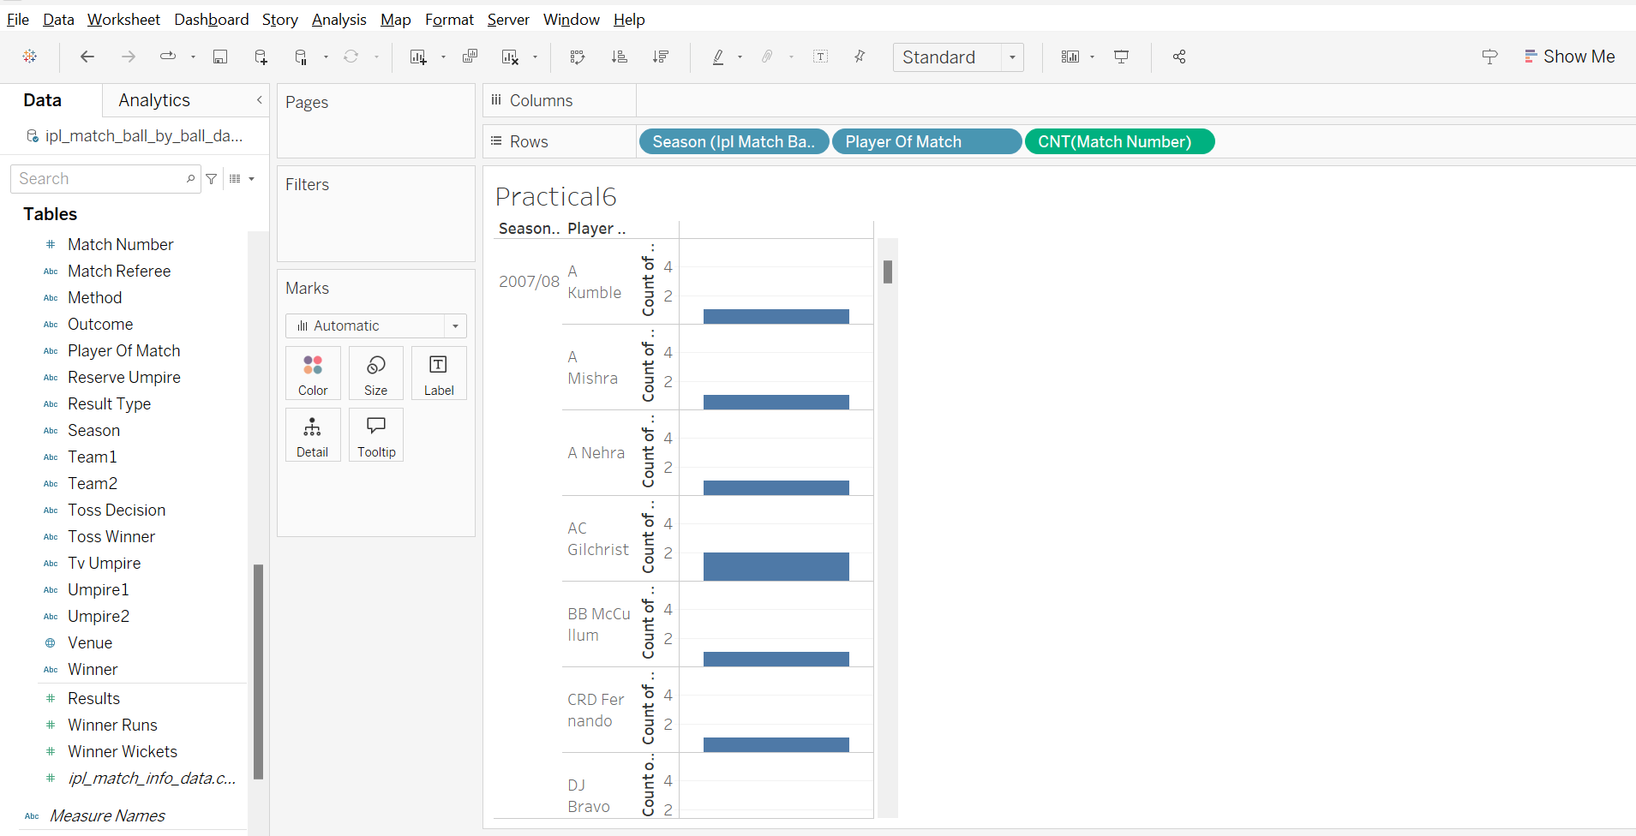

* Go to Show Me and Select TreeMaps

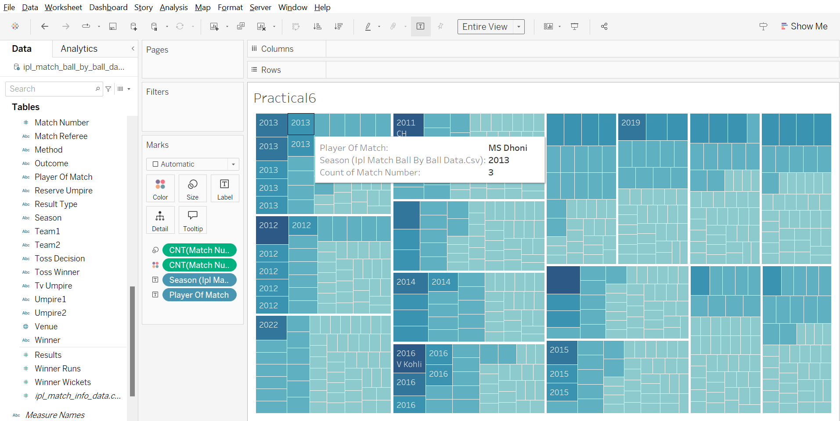

**Treemap of POTM (Player of the match) Season wise using Rows Player Of Match, Season and Match Number match and Name of Player as Label.**

1. **Create a map to show the geographic distribution of data**

* **Definition:** A geographic map is a flat representation of part of the Earth's surface that shows geographic features, such as bodies of water, landforms, and cities.
* **Application:** A geographic map is used to visually represent the Earth's surface, allowing people to understand the location of places, analyse spatial relationships between features, plan routes, study geographical patterns, and gain insights into various aspects.
* **Dataset / Data source:** IPL Season (2008 - 2022)

Same dataset is used as Practical 1 (IPL Season (2008-2022))

* Drag City field to Rows and apply filter to reduce city

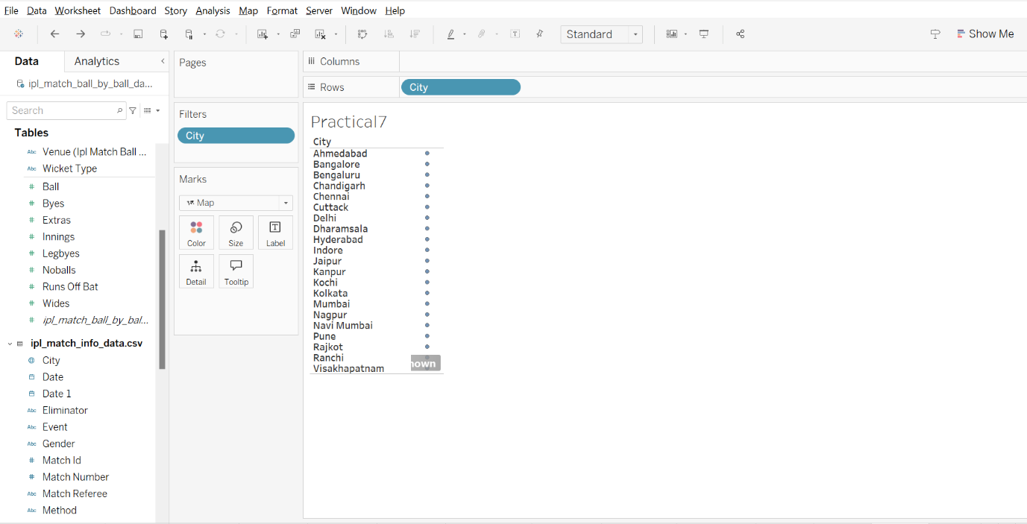

* Go to Show Me and convert the text chart to Geographic chart and click on unknown location and add India as Country.

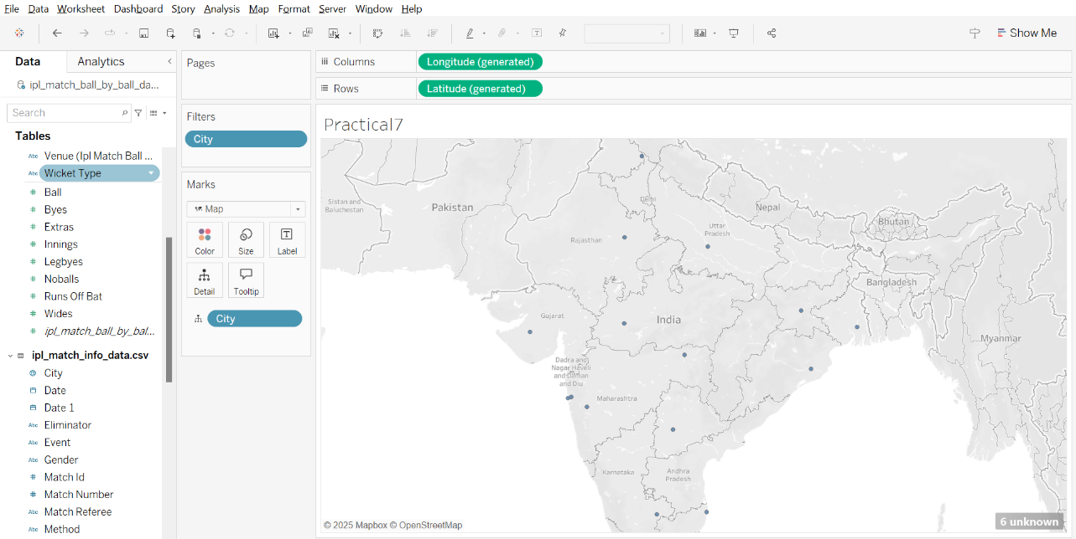

* Drag City to Label and Match Number to Text by convert measure to count

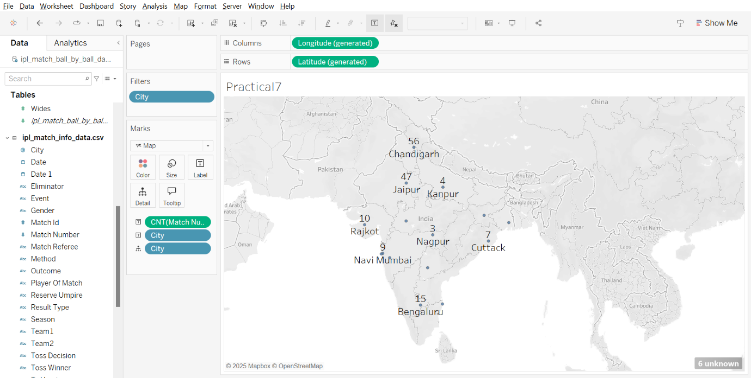

1. **Create a dashboard to combine multiple visualizations into a single view.**

* **Definition:** A dashboard is a visual interface that displays key metrics, data, and insights in a structured and interactive way. It helps users monitor, analyze, and make decisions based on real-time or aggregated information.
* **Application:** Dashboards are used in various fields, including Business Analytics, Finance, Healthcare, IT & System Monitoring, Project Management, Education.
* **Dataset / Data source:** IPL Season (2008 - 2022)

Same dataset is used as Practical 1 (IPL Season (2008-2022))

Dashboard 1:

1. Drag 1st worksheet to dashboard area then click on more option and change to floating.

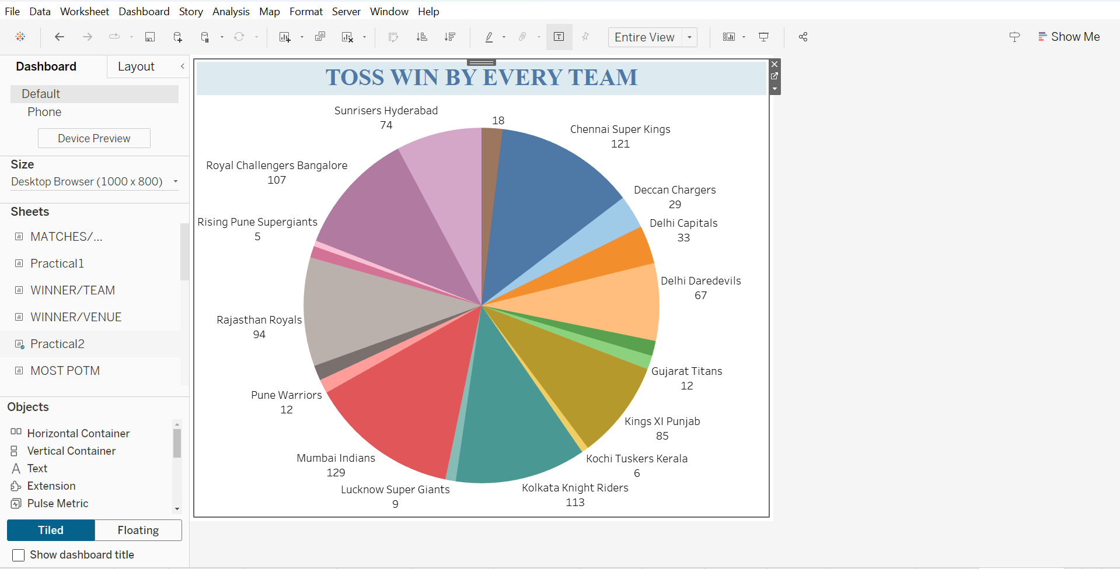

**Dashboard 1: Final Result**

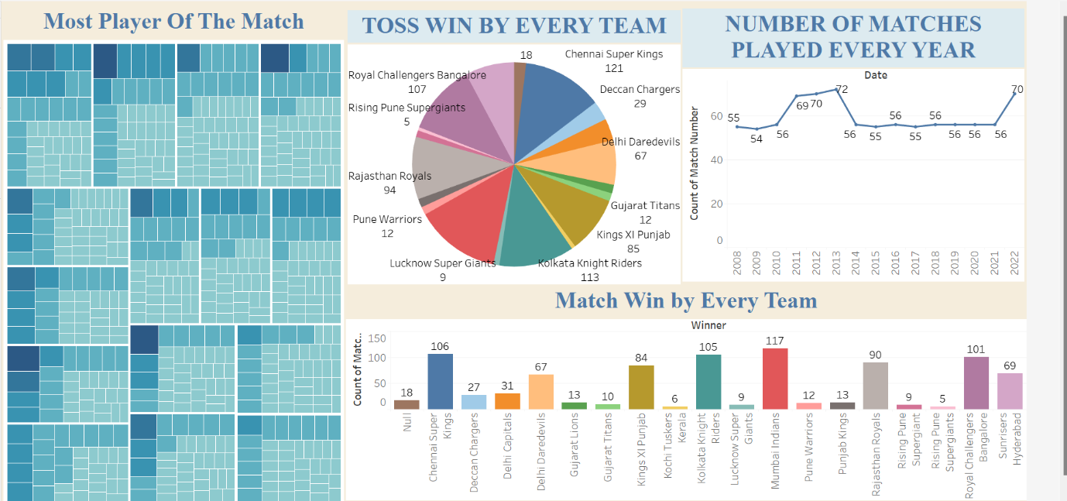

When click on any element of worksheet which in included in dashboard (Eg. RCB)

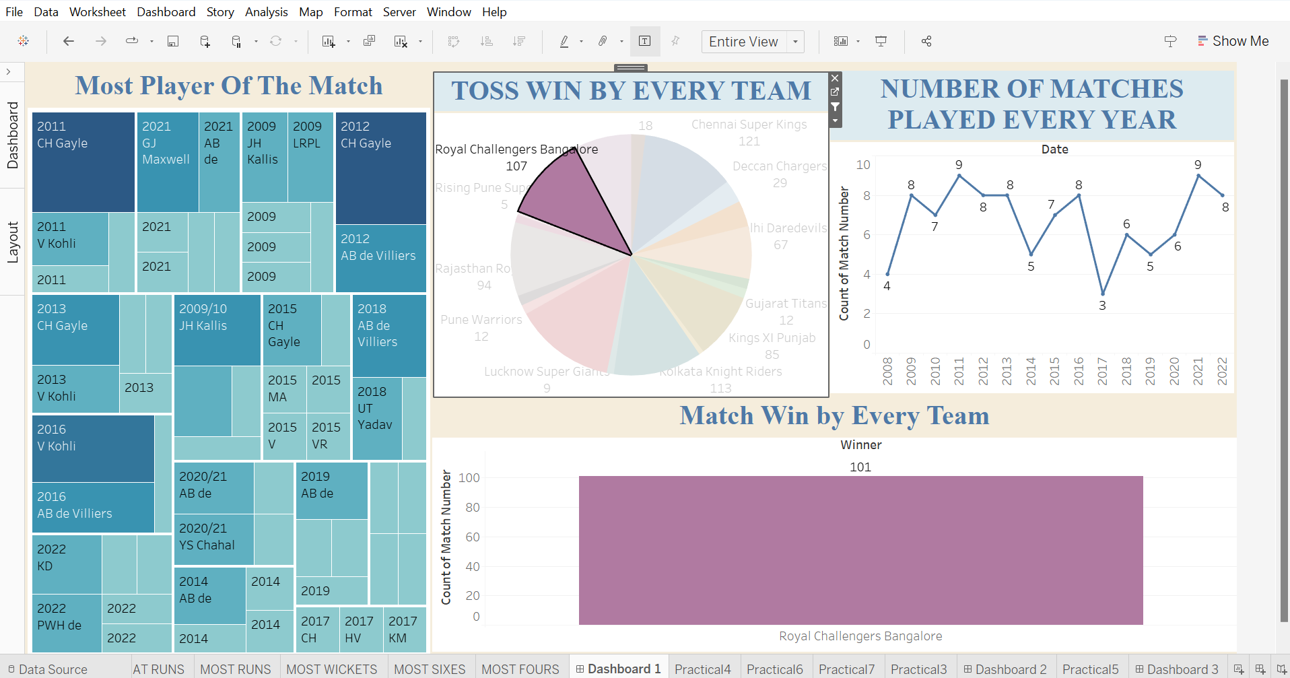

**Cricket Match Analysis Dashboard**: It helps analyse team performance, trends, and key match statistics effectively.

This interactive Cricket Match Analysis Dashboard consolidates insights from multiple worksheets to provide a comprehensive view of match statistics. It includes:

* Player of the Match: Displays the most awarded players with their total awards.
* Toss Wins by Team: Analyses how often each team has won the toss.
* Matches Played Per Year: Shows the number of matches held annually.
* Match Wins by Team: Highlights the total matches won by each team.

Dashboard 2:

Drag 1st worksheet to dashboard area then click on more option and change to floating.

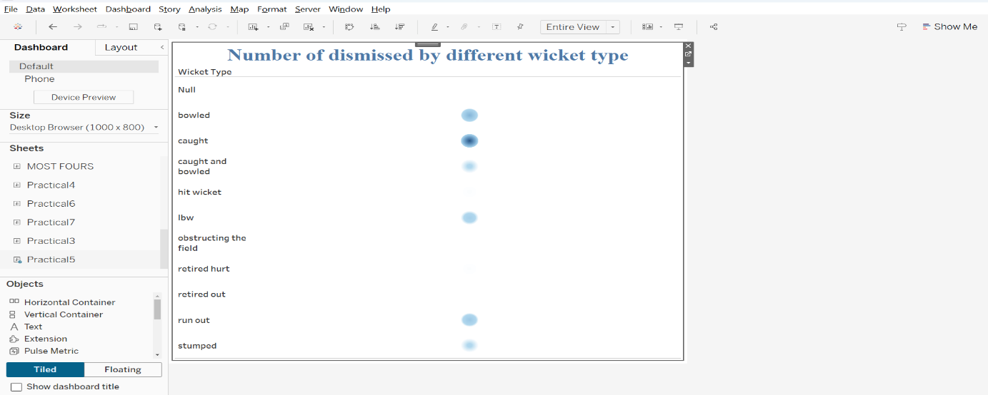

**Dashboard 2: Final Result**

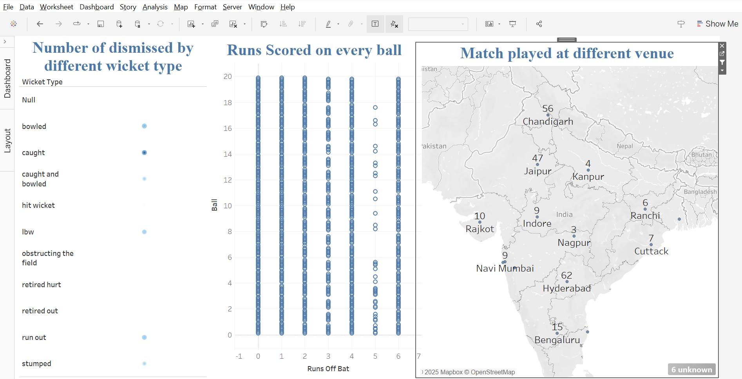

**Cricket Match Insights Dashboard**: It helps cricket analysts and fans understand player performance, scoring trends, and venue-based match distribution.

This Cricket Match Insights Dashboard provides a detailed analysis of match dynamics using multiple worksheets:

* Player Dismissals by Wicket Type: Displays the number of players dismissed by different modes (bowled, caught, LBW, etc.).
* Runs Scored on Every Ball: Tracks the runs scored per delivery, highlighting scoring patterns.
* Matches Played at Different Venues: Analyses the distribution of matches across various stadiums.

1. **Use filters and groups to explore your data in different ways.**

* **Definition:** Filters in Tableau allow users to restrict and refine the data displayed in visualizations. Filters help in analyzing specific data subsets by removing unwanted data.

Groups in Tableau allow users to combine related values into a single category. This is useful when multiple values need to be treated as one entity in analysis.

* **Application:** Filters in Tableau are widely used for data analysis and visualization.
* Data Restriction
* Comparative Analysis
* Interactive Dashboards
* Performance Optimization
* Focused Insights
* Dynamic Date Filtering
* **Dataset / Data source:** IPL Season (2008 - 2022)

Same dataset is used as Practical 1 (IPL Season (2008-2022))

Right click on any worksheet -> select filter -> field to create filter and then apply that filter to all data sources for filtering whole dashboard.

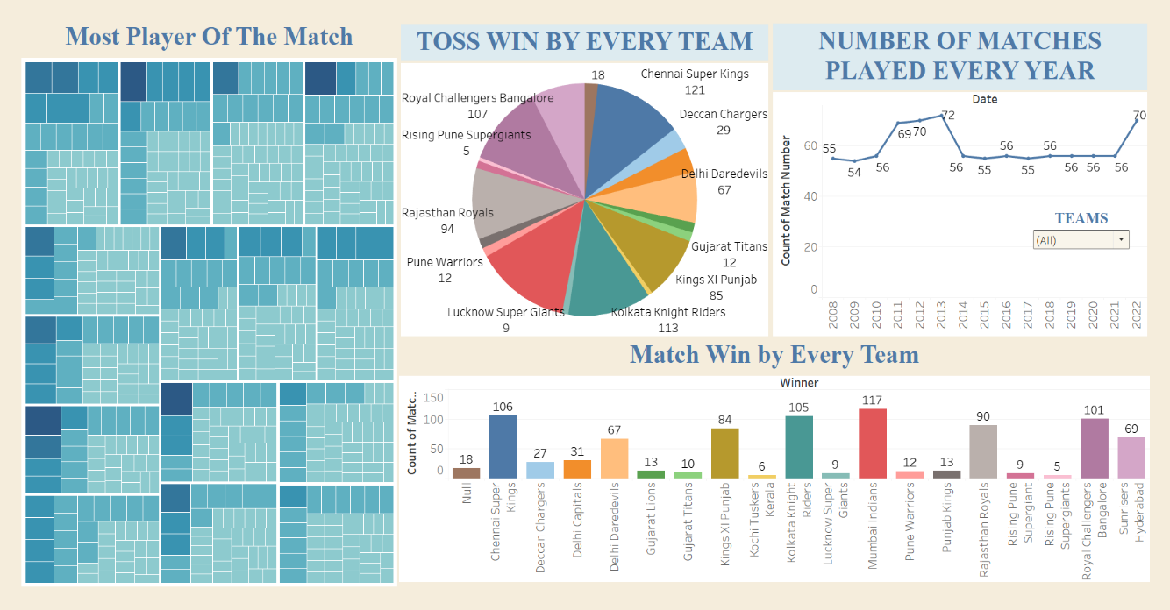

**Filtering All teams using created filter**

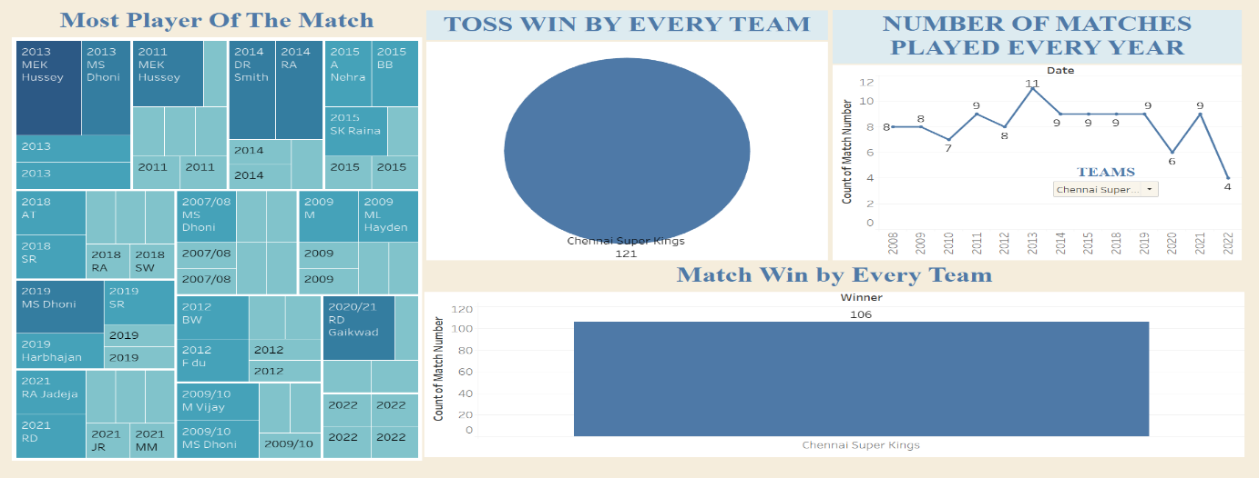

**Filtering Chennai Super Kings (CSK) in dashboard**

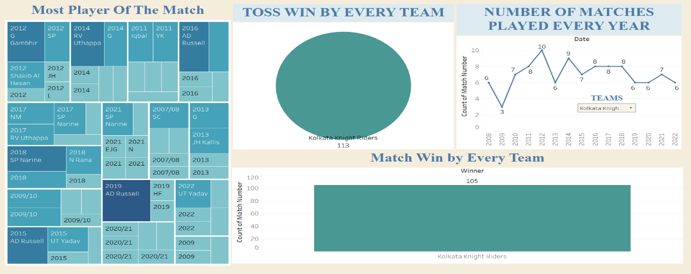

**Filtering Kolkata Knight Riders (KKR) in dashboard**

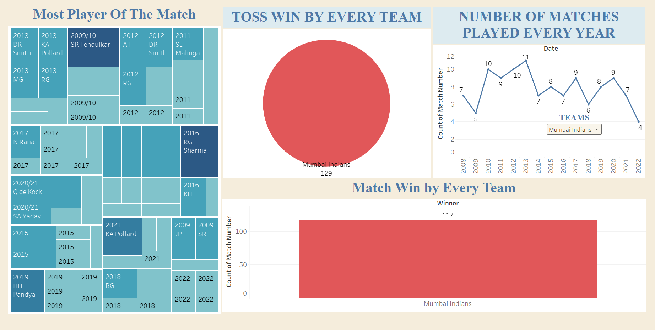

**Filtering Mumbai Indians (MI) in dashboard**

**2. Create a pie chart to show the distribution of data.**

* **Definition:**
* **Applications:**
* **Dataset / Data Source**

Sample – Superstore

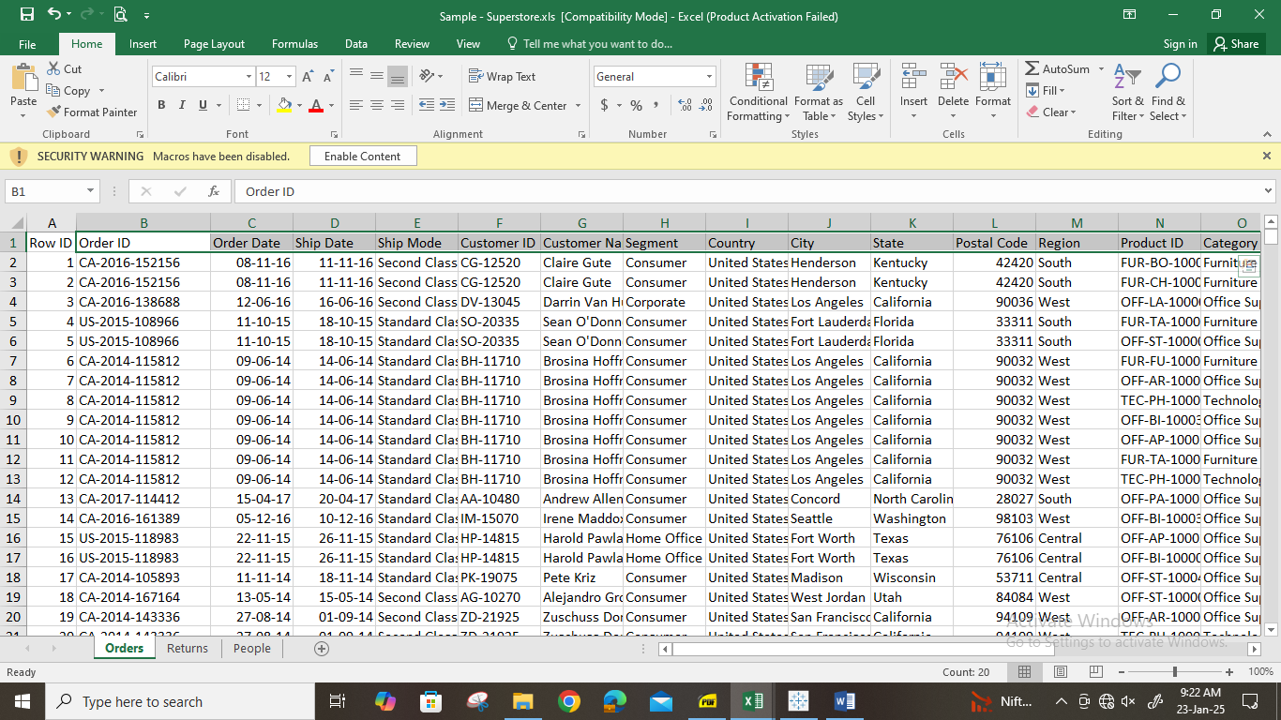

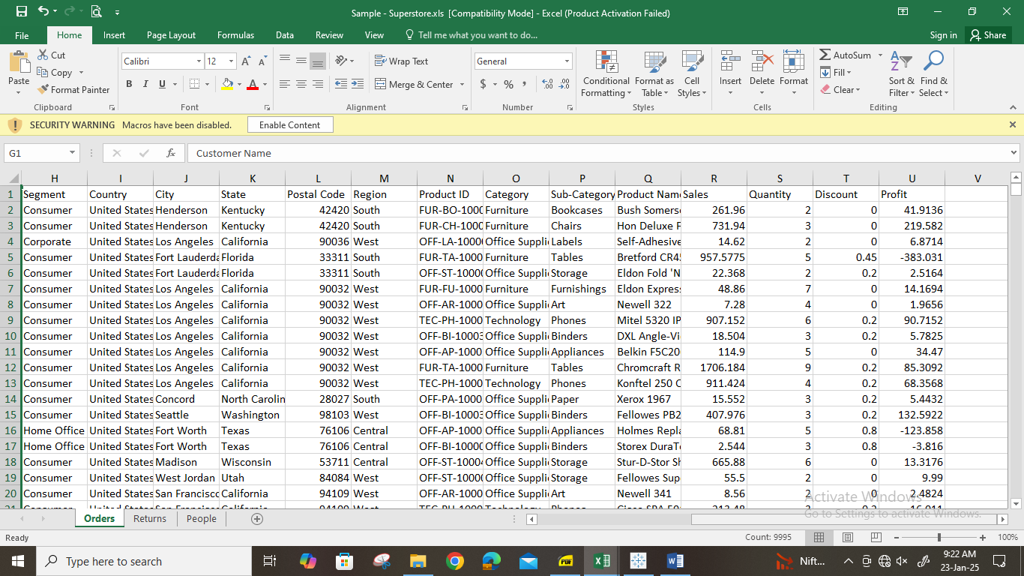

* Import the relavant dataset in tableau

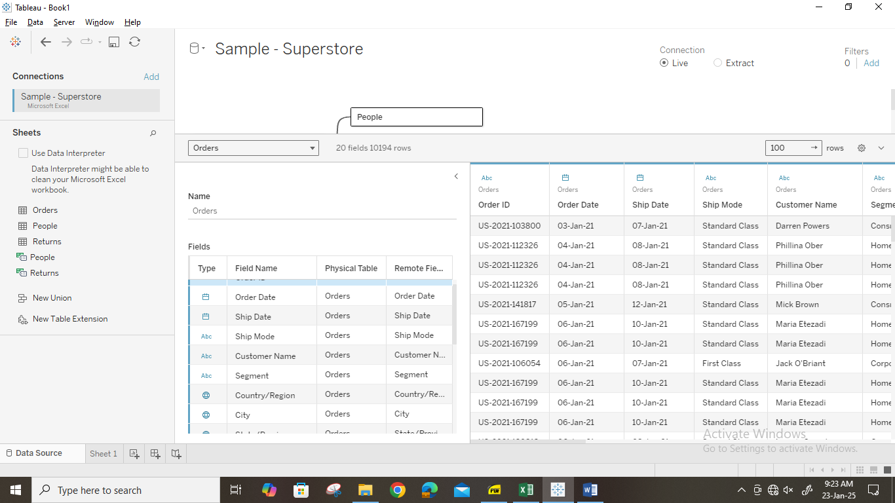

* Drag a product in to rows/ columns

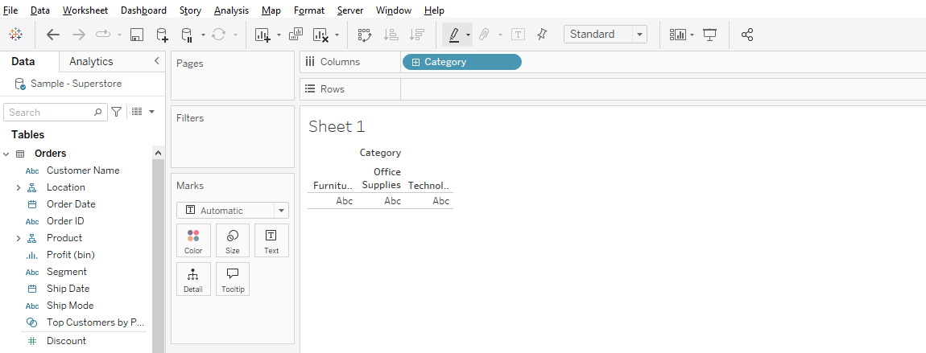

* Use sales measure to generate a graph

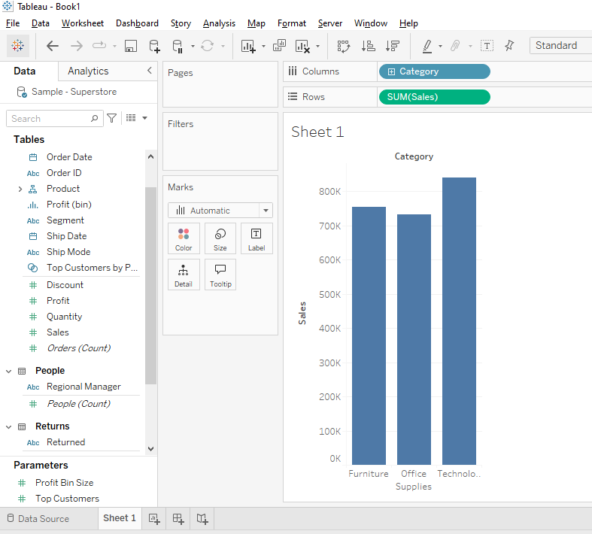

* Pie Chart

